**4. Docker Basics**

1. List few benefits of docker

* Isolation
* Portability
* Resource efficiency
* Scalability
* Easy maintenance and updates

1. Install docker
2. Check docker version and copy the output
3. Create a new java project with maven
4. Create a main class and print “Hello docker example”
5. Create a jar file for the project (inside target directory)
6. Run the generated jar file inside target directory with command line
7. Display the output

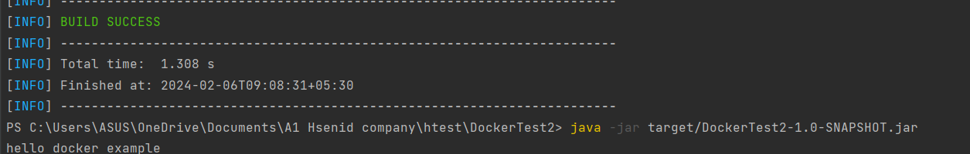

1. Create a docker image for the java project. What is the command you used?

docker build -t docker-example-two .

1. List all the docker images and show output

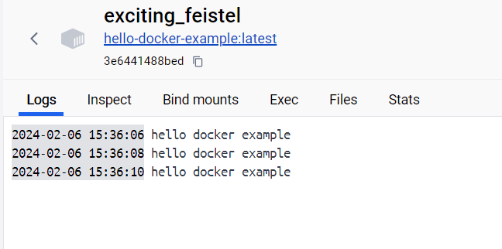

1. Run the created docker image. What is the command you used?

docker run --name my-java-app docker-example-two

1. List all the docker images and show output

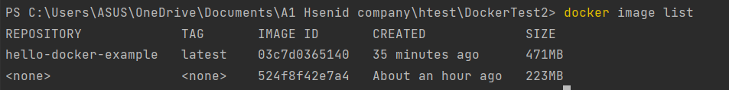

1. Stop the docker container?

docker stop my-java-app

1. List all the docker containers and show output
2. Remove the docker image. What is the command you used?

docker rmi hello-docker-example

1. List all the docker images and show output
2. What is docker hub?

Docker hub is repository service and it is a cloud-based service easiest way to create, manage,and deliver team container applications.

1. Pull hello-world image from docker hub

docker pull hello-world

1. Run hello-world image and show output

docker run hello-world

1. Pull and run mongodb as docker container

Docker pull mongo

1. Open mongo shell

docker exec -it mongo mongosh

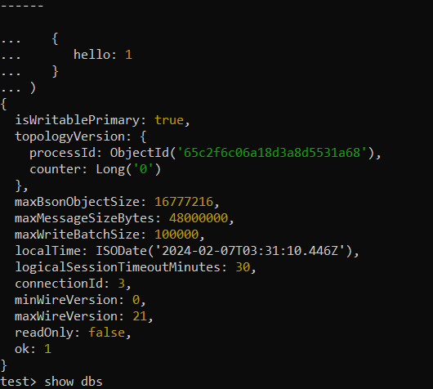

1. List mongodb databases
2. Add your codes and answer sheet to a directory named “docker-basic-training” and push it to your training github repository

